Describing Simulations of Earth System Features using the Metafor CIM

The physical earth system may be conceptualised as a collection of features. The way in which these features operate, evolve and effect each other can be simulated, and we refer to the simulated version of the real world feature as a process. Processes may contain sub-processes. For example, the ocean is a feature whose operation can be seen as a process with a series of sub-processes.

Real world features may be conceptualised as ‘black boxes’ having inputs and outputs. The inputs influence the way the process operates, and are of two types: initial process state or constant values that describe physical laws of nature and that do not change (for example, gravity), and variable values that may change over time as the feature operates and evolves (for example, sea surface temperature that might change over time).

Metafor seeks to describe these simulations. The remainder of this document explains how Metafor does this, and is accompanied by a running example for the Ocean and Atmosphere processes for illustrative purposes. This is intended for an audience with minimal knowledge of climate science.

Metafor has created a set of controlled vocabularies to support CMIP5 and for use with the CIM (Metafor conceptual model). These controlled vocabularies identify 8 real world features (referred to as realms) that are implicitly part of the earth system model (ESM):
- Aerosols
- Atmosphere
- Atmospheric Chemistry
- Land Ice
- Land Surface
- Ocean
- Ocean Biochemstry
- Sea Ice.

Each of the 8 major real world features is simulated as a process which has a further set of simulated sub-processes, each of which may have their own sub-processes nested potentially infinitely.

Description | Elements in UML Model | Running Example
Real world features are described in the Domain Feature Catalogue, which is another application schema that extends ISO 19110 and that is used by the CIM.  Numerical Processes  Numerical processes have been developed to describe the real-world features, to simulate how they might operate in the real world. Some of these processes describe a particular process as a series of sub-processes, while others define an actual algorithm for the higher level process itself, rather than considering the process as an amalgamation. Very high level processes like the ESM are usually modelled as a series of sub-processes, while lower level processes are usually modelled as processes in their own right.  As with the real world feature that the numerical process simulates, input values can be passed into the process, which returns output values. Theoretically, if the input value is the same as a real world measurement for the relevant variable, the output values should also reflect what would be found in the real world. In this way, the models can be used to test the effects of a change in the input values. These models are generally used to perform simulations over time.  In the Metafor CIM, numerical processes have descriptions. Firstly, the process has a scientific description. This describes the science that is involved in the process, including the algorithm that is behind it: a formula and/or set of steps that describes in precise and formal (usually mathematical) terms how the process operates and how the different inputs influence the outputs.  Secondly, the process has a software description. This describes the software that implements the process. The software description mainly consists of a reference to the actual source code.  Both software and science descriptions may have sub-descriptions. Sometimes the way a science description is broken into sub-descriptions and the way a software description is broken into sub-descriptions (that is, sub-routines or sub-programmes) are not the same. Thus each description has its own hierarchy.  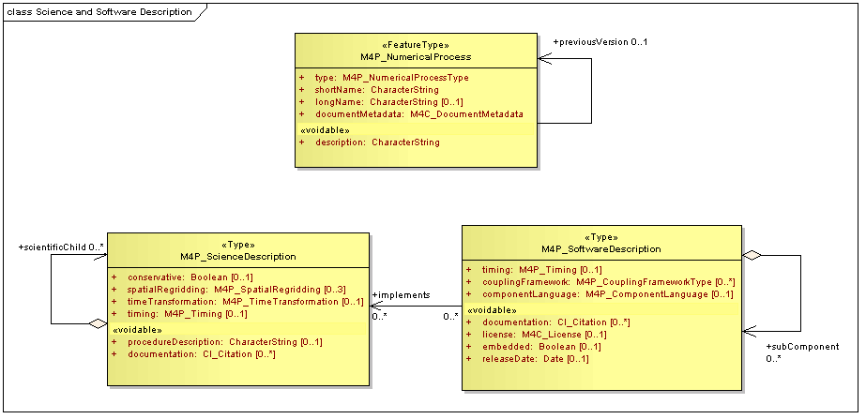  Numerical processes usually have a number of options attached to them that indicate the ways in which the process may be executed. Before the specific choices for these options have been made, they are referred to as unconfigured processes. Once particular values have been attached, they are referred to as configured processes. Similarly, the scientific description and software description for a model is referred to as unconfigured when a set of options are available but the choice of which to use has not yet been made, and configured once specific choices for the execution of the process have been made.  A generic scientific process, including its algorithm and the possible configuration parameters that are available, is described as an unconfigured process. Once a set of configuration parameters have been selected for the process (with a view to performing a simulation), it is then referred to as a configured process. Thus the unconfigured process describes the algorithm and the configuration parameter options, and the assignment of configuration parameters turns it into a configured process.  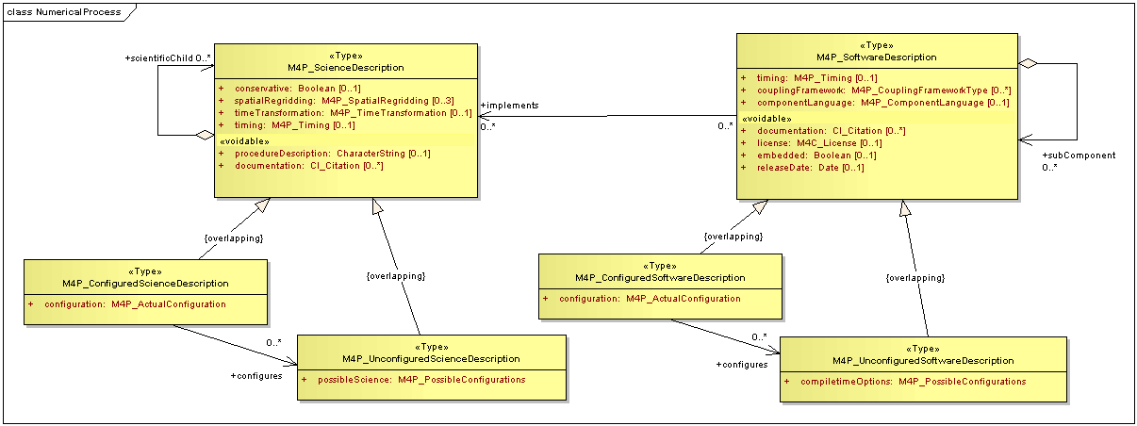  Unconfigured scientific processes have a set of configuration options, from which the final configuration values may be selected. They include:  - Properties for which there is more than one option for which a selection must be made to execute the properties. The range of possible values for these parameters, along with the processes themselves, are all stored in the Metafor controlled vocabularies, created from mind maps.  - Particular properties that the process may use as inputs or outputs. A possible configuration may identify a range of properties, while the actual configuration may identify only a subset.  - The interactions among sub-processes that make up the process. These describe the sets of interactions in which the outputs from one sub-process become inputs into another sub-process, or interactions in which a sub-process takes data from a particular storage location, or writes it to such a location. An unconfigured process may identify a range of possible interactions, while a configured process will identify the actual interactions that make up the configured process.  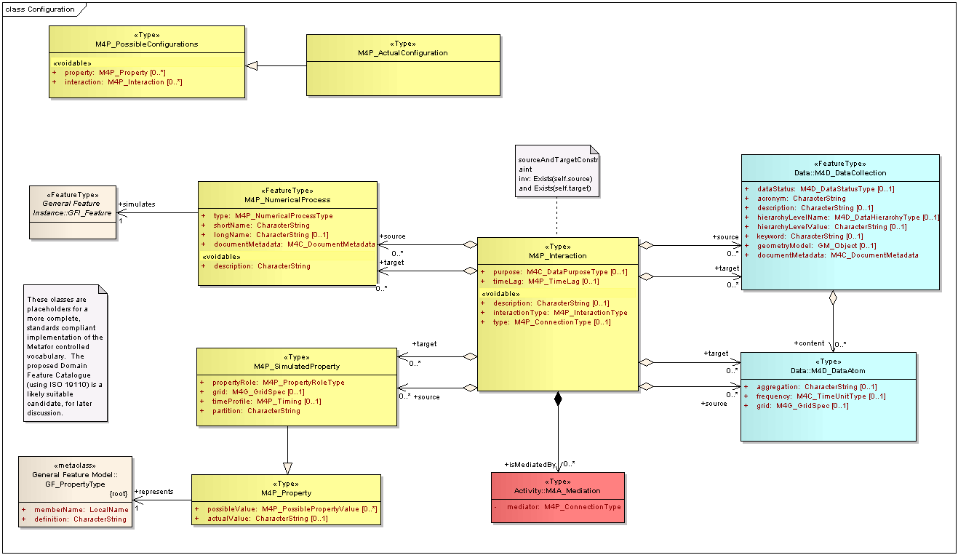  Simulations  Numerical processes are implemented as software to allow repeated running of simulations with different input values, or with different configuration parameters. When the configured process is run with some software, it becomes a simulation. Simulations usually involve a series of time steps, in which the simulation is run over a particular time period with the algorithm being executed repeatedly while time is increased for each execution.  It is helpful to think of simulations as having two sorts of inputs: those that are read at the beginning and don't change, and those which need to be read at intervals as the model is run. The former are called initial conditions, the latter boundary conditions. The data for boundary conditions may come from another simulation or from observations. When and how boundary conditions are required is an important characteristic of a process description.  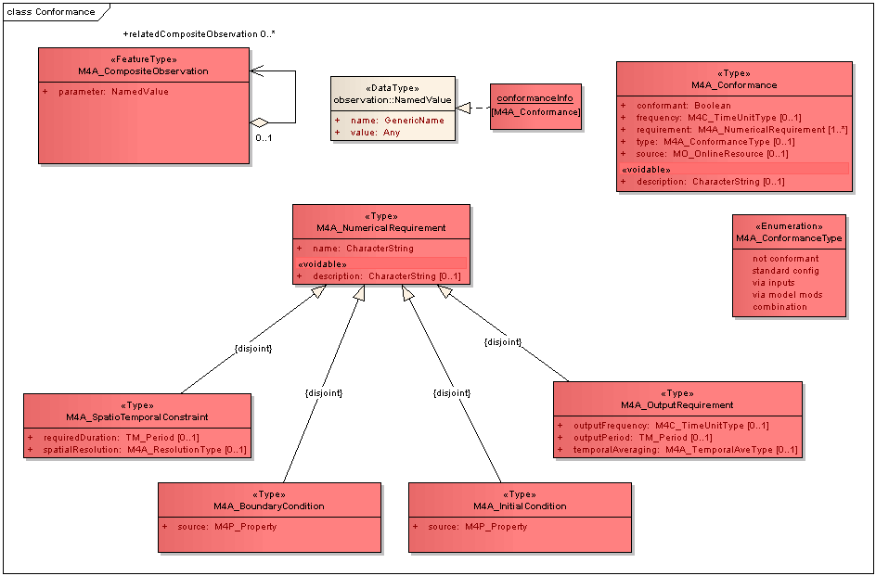  It is also possible for changes to the simulation to be made at run-time. Such changes may include changes to the code, to the entire configuration, or to specific parameter values.  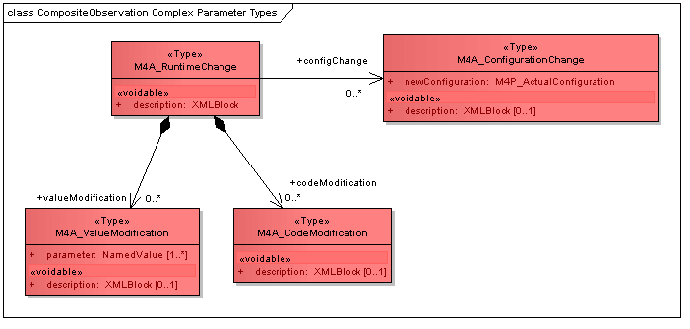 | DFC_DomainFeature, content populated with Metafor controlled vocabularies.  M4P_NumericalProcess  M4P_Scientific Description  M4P_SoftwareDescription  M4P_ConfiguredProcess, M4P_UnConfiguredProcess, M4P_ConfiguredScienceDescription, M4P_UnconfiguredScienceDescription, M4P_ConfiguredSoftwareDescription, M4P_UnconfiguredSoftwareDescription  M4P_PossibleConfigurations, M4P_ActualConfiguration  M4A_CompositeObservation  M4A_InitialCondition, M4A_BoundaryCondition, M4A_Conformance  M4A_RuntimeChange | In our running example, we focus on the Ocean and Atmosphere features.  We have a numerical process for the Ocean and another for the Atmosphere. Our processes define an algorithm in their own right, rather than as amalgamations of other processes.  Our Ocean model requires inputs for sea-ice state and atmosphere temperature. It has a number of outputs, one of which is sea surface temperature (SST). Our Atmosphere model requires inputs for SST (which comes from the output of the Ocean model) and ozone level; and has a number of outputs. These inputs for both models are all variable inputs, but sea-ice state, atmosphere temperature and ocean temperature vary constantly and quickly, while ozone level varies slowly.  Atmos.xml and Ocean.xml describe the models in xml files that reference values in the Metafor controlled vocabularies.  AtmosSW.xml and OceanSW.xml describe the software in xml files that reference values in the Metafor controlled vocabularies. The code for our two models are stored in Atmos.F and Ocean.F (Fortran source code)  Our Atmosphere process requires selection of a property for cloud scheme. The process may use one of two different cloud schemes: the Smith80 cloud scheme or the Smith90 cloud scheme. Once one of these has been selected (together with other configuration details), the Atmosphere process becomes a configured process.  Atmos.XML and Ocean.XML describe the properties and interactions for the unconfigured process and AtmosSW.XML and OceanSW.XML describe the properties and interactions for the unconfigured software. Ocean.F reads sea-ice from Fortran unit 10, while Atmos.F reads ozone from Fortran unit 11.  Once the configuration values have been selected, ActualAtmos.XML and ActualOcean.XML describe the properties and interactions for the configured process (which are scientific descriptions with the Smith90 cloud scheme selected), and we bind our software to specific input values as follows:  - FOR010 binds to sea-ice.nc  - FOR011 binds to ozone.nc  - FOR012 binds to output.nc.  We would like to run a simulation of the ocean and the atmosphere using our ocean and atmosphere processes. We want to run a simulation for 100 years with the model software being executed once every day (our timestep). Thus the model software will run 36400 times.  The atmosphere requires an initial temperature, and it needs to know the sea-ice state every day. The former is an initial condition, the latter a boundary condition. The atmosphere also needs to know the ozone as a boundary condition, but it only needs that updated every month. The atmosphere also needs to know the SST, updated every day. SST is simulated by the ocean. In this instance, the atmosphere updates the ozone and sea-ice from external files, and the SST from the running ocean model outputs.  The configuration for the simulation may have originally specified that the data for sea-ice to come from a particular source, but at run-time, this source may be unavailable, and another one nominated as a replacement.

